Subject: Machine Learning – I (DJ19DSC402) AY: 2022-23

Experiment 8 (SVM)

**Aim:** Perform SVM using soft margin SVC, Kernels and improve the accuracies using hyperparameter tuning.

# Theory:

The objective of the support vector machine algorithm is to find a hyperplane in an N-dimensional space(N

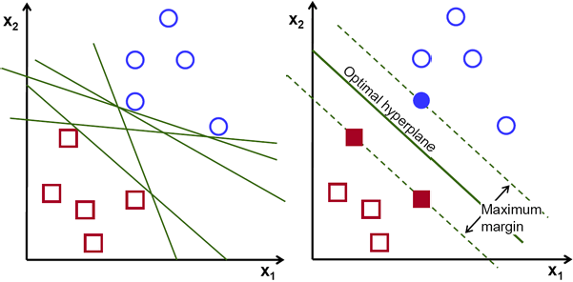— the number of features) that distinctly classifies the data points.

Possible hyperplanes

To separate the two classes of data points, there are many possible hyperplanes that could be chosen. Our objective is to find a plane that has the maximum margin, i.e the maximum distance between data points of both classes. Maximizing the margin distance provides some reinforcement so that future data points can be classified with more confidence.

Hyperplanes and Support Vectors

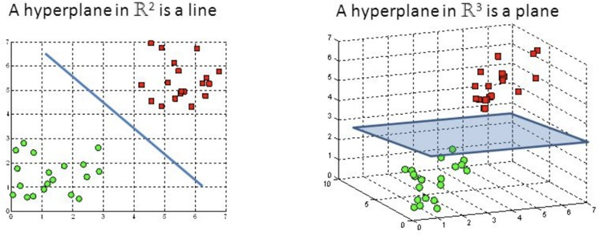

Hyperplanes in 2D and 3D feature space: Hyperplanes are decision boundaries that help classify the data points. Data points falling on either side of the hyperplane can be attributed to different classes. Also,

the dimension of the hyperplane depends upon the number of features. If the number of input features is 2, then the hyperplane is just a line. If the number of input features is 3, then the hyperplane becomes a two-dimensional plane. It becomes difficult to imagine when the number of features exceeds 3.

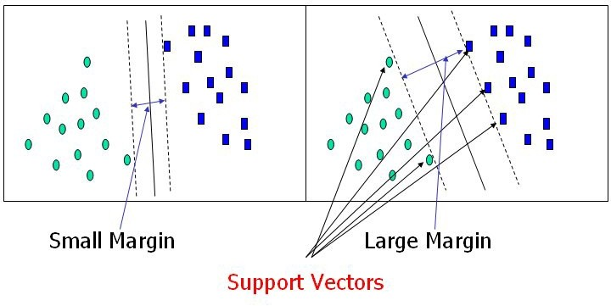

Support vectors are data points that are closer to the hyperplane and influence the position and orientation of the hyperplane. Using these support vectors, we maximize the margin of the classifier. Deleting the support vectors will change the position of the hyperplane. These are the points that help us build our SVM.

Large Margin Intuition

In logistic regression, we take the output of the linear function and squash the value within the range of [0,1] using the sigmoid function. If the squashed value is greater than a threshold value(0.5) we assign it a label 1, else we assign it a label 0. In SVM, we take the output of the linear function and if that output is greater than 1, we identify it with one class and if the output is -1, we identify is with another class.

Since the threshold values are changed to 1 and -1 in SVM, we obtain this reinforcement range of values([-1,1]) which acts as margin.

Cost Function and Gradient Update: In the SVM algorithm, we are looking to maximize the margin between the data points and the hyperplane. The loss function that helps maximize the margin is hinge loss.

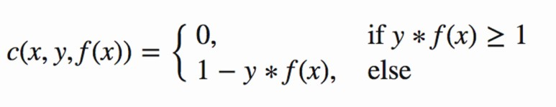



Hinge loss function (function on left can be represented as a function on the right)

The cost is 0 if the predicted value and the actual value are of the same sign. If they are not, we then calculate the loss value. We also add a regularization parameter the cost function. The objective of the

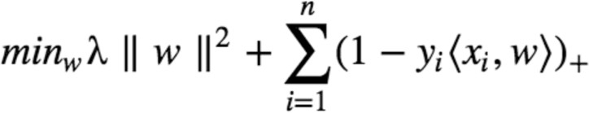regularization parameter is to balance the margin maximization and loss. After adding the regularization parameter, the cost functions looks as below.

Loss function for SVM

Now that we have the loss function, we take partial derivatives with respect to the weights to find the gradients. Using the gradients, we can update our weights.

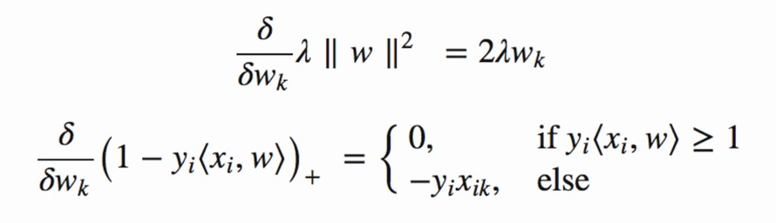

Gradients

When there is no misclassification, i.e our model correctly predicts the class of our data point, we only have to update the gradient from the regularization parameter.

Gradient Update — No misclassification

When there is a misclassification, i.e our model make a mistake on the prediction of the class of our data point, we include the loss along with the regularization parameter to perform gradient update.



Gradient Update — Misclassification

# Lab Assignments to complete in this session:

Use the given dataset and perform the following tasks:

# Dataset 1: IRIS.cvs

**Dataset 2: mnist_784 :** The MNIST database of handwritten digits with 784 features, raw data available at: [http://yann.lecun.com/exdb/mnist/.](http://yann.lecun.com/exdb/mnist/) It can be split in a training set of the first 60,000 examples, and a test set of 10,000 examples. It is a subset of a larger set available from NIST. The digits have been size- normalized and centered in a fixed-size image. It is a good database for people who want to try learning techniques and pattern recognition methods on real-world data while spending minimal efforts on preprocessing and formatting. The original black and white (bilevel) images from NIST were size

normalized to fit in a 20x20 pixel box while preserving their aspect ratio. The resulting images contain grey levels as a result of the anti-aliasing technique used by the normalization algorithm. the images were centered in a 28x28 image by computing the center of mass of the pixels, and translating the image so as to position this point at the center of the 28x28 field.

**Task 1:** Build a linear classifier on Dataset 1 using SVC.

**Task 2:** Build a classifier on Dataset 1 using Linear, Polynomial and RBF kernel and show the decision boundary using matplotlib.

**Task 3**. Find the accuracy of svc classifier (M1) built on Dataset 3 using linear csv and RBF kernel. **Task 4:** Improve the accuracy of M1 by varying C and gamma values and using RandomizedSearchCV. **Task 5:** Calculate the computational time of Task 3 and 4.

TASK 1:

**TASK 2:**

**TASK 3:**

**TASK 4:**

